Ship It
RULES: Practical Shooting Handbook, Latest Edition COURSE DESIGNER: Kirt McKenna
START POSITION: Standing inside of the shooting area. Handgun is loaded and holstered, one hand is touching the X on the wall.
PCC START: Same as handgun with muzzle touching the X on the wall.
STAGE PROCEDURE  On start signal engage targets as they become visible, from within the shooting area. | SCORING  SCORING: Comstock, 12 rounds, 60 points  TARGETS: 6 USPSA  SCORED HITS: 2 Best per USPSA  START-STOP: Audible - Last shot  PENALTIES: Per current USPSA rulebook
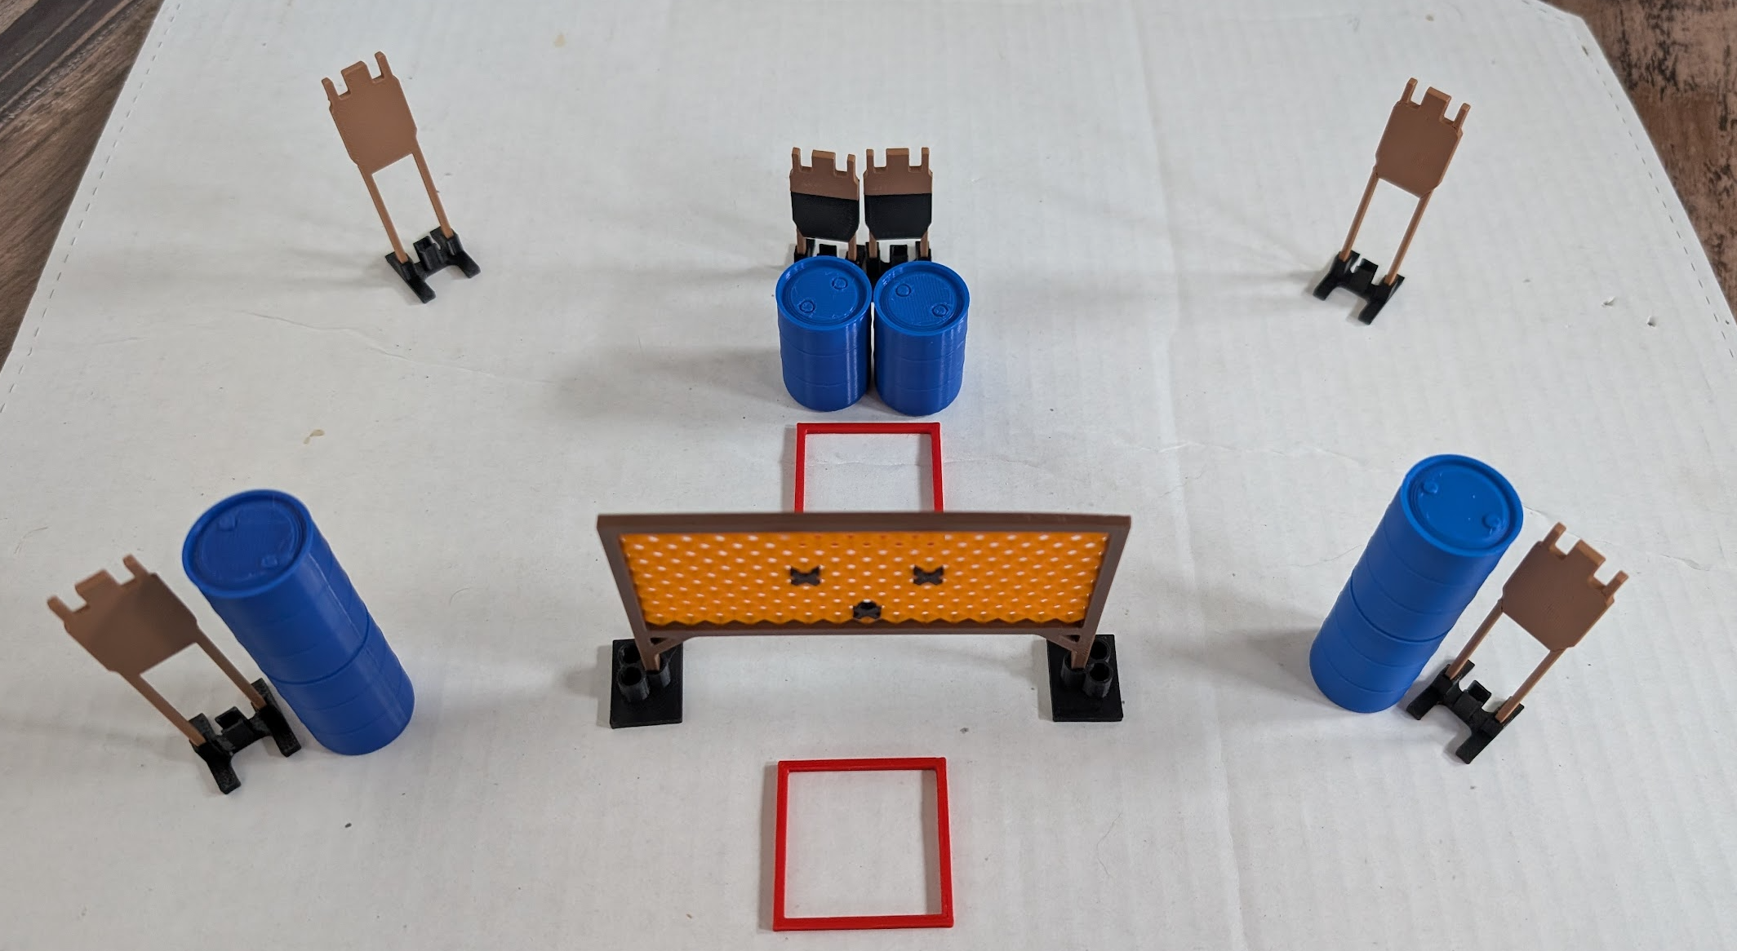

SETUP NOTES: |  | RO NOTES:

